**Cloud Data Loss Prevention Lab-1**

In this hand-on demo, you will put into context all the concepts of Cloud Data Loss Prevention and apply them to a real-world scenario where sensitive data is present.

1. To understand the purpose of the Cloud Data Loss Prevention service, you first go to Cloud Storage in the console and create a bucket. Click on *“Navigation menu”* on top left, then click on *“Cloud Storage” → “Buckets”*

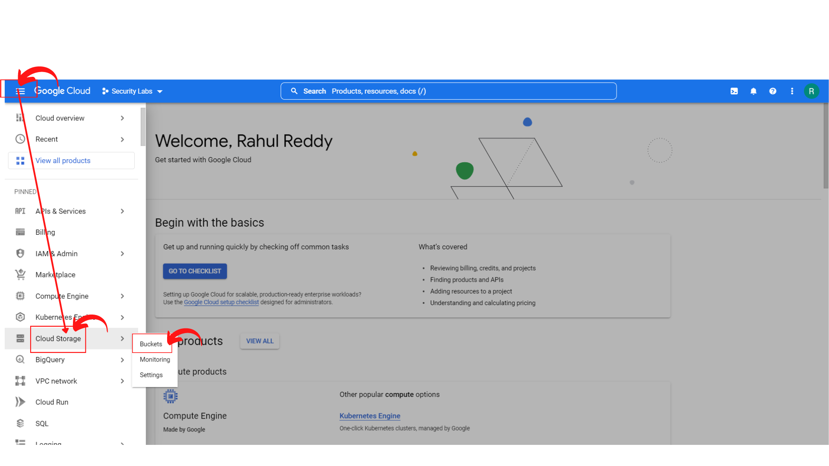

1. Your screen should look similar and click → *“Create”* or Click → *“Create Bucket”* to create a storage bucket.

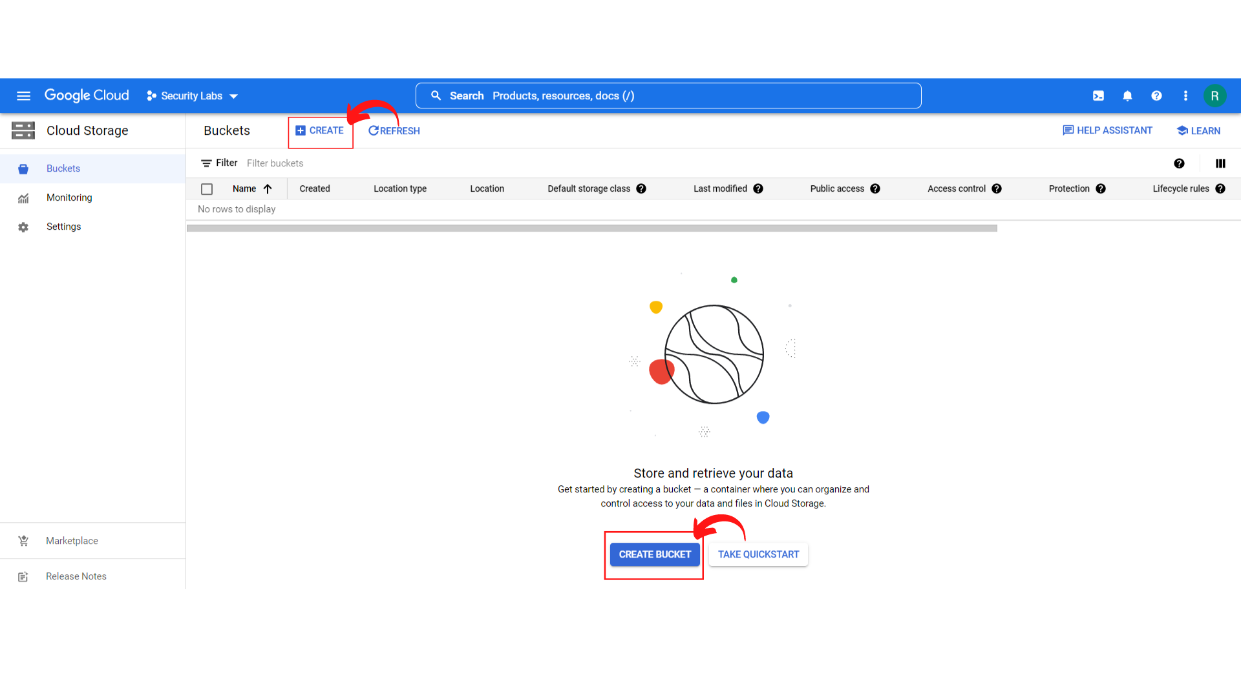

1. Your screen should look similar.

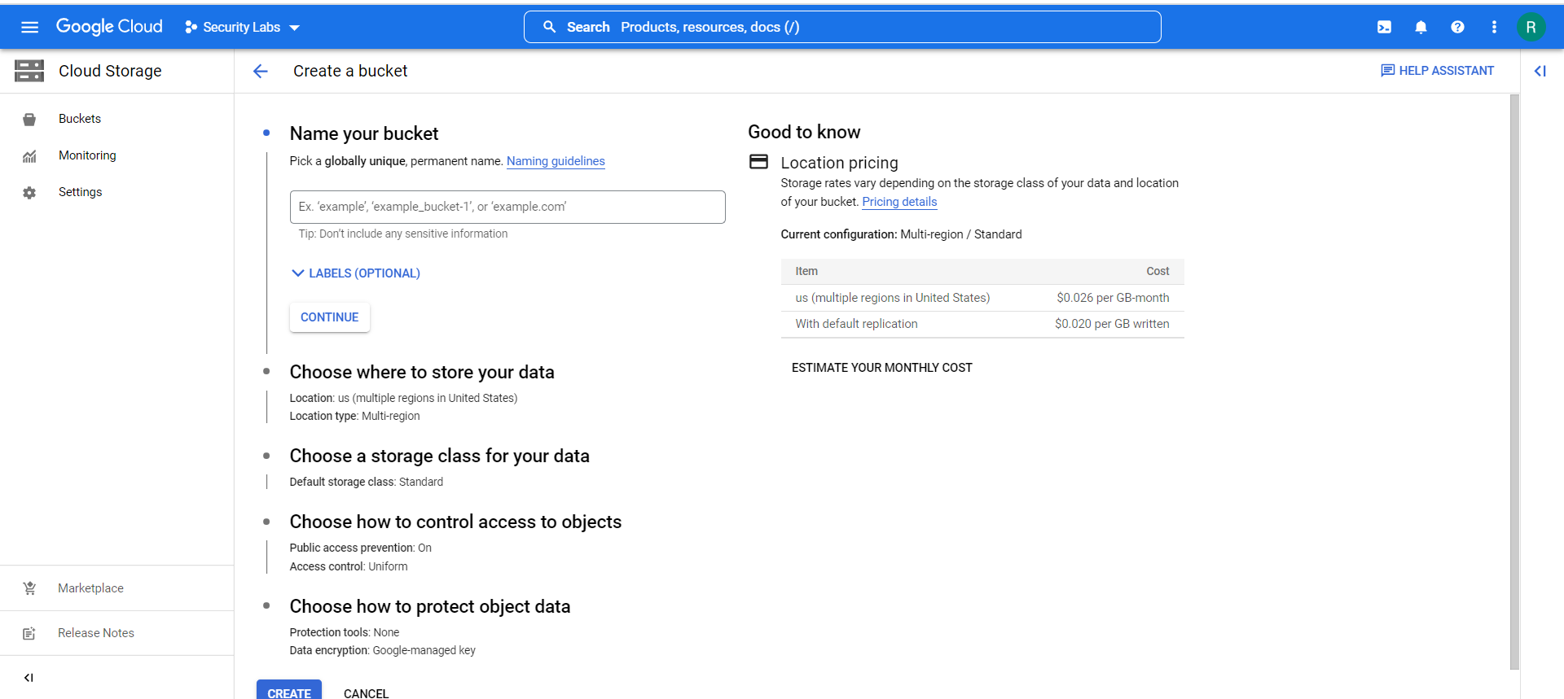

1. Now *Enter the Name of your Bucket* as per your choice and then *click → Continue*

Example: security-labs

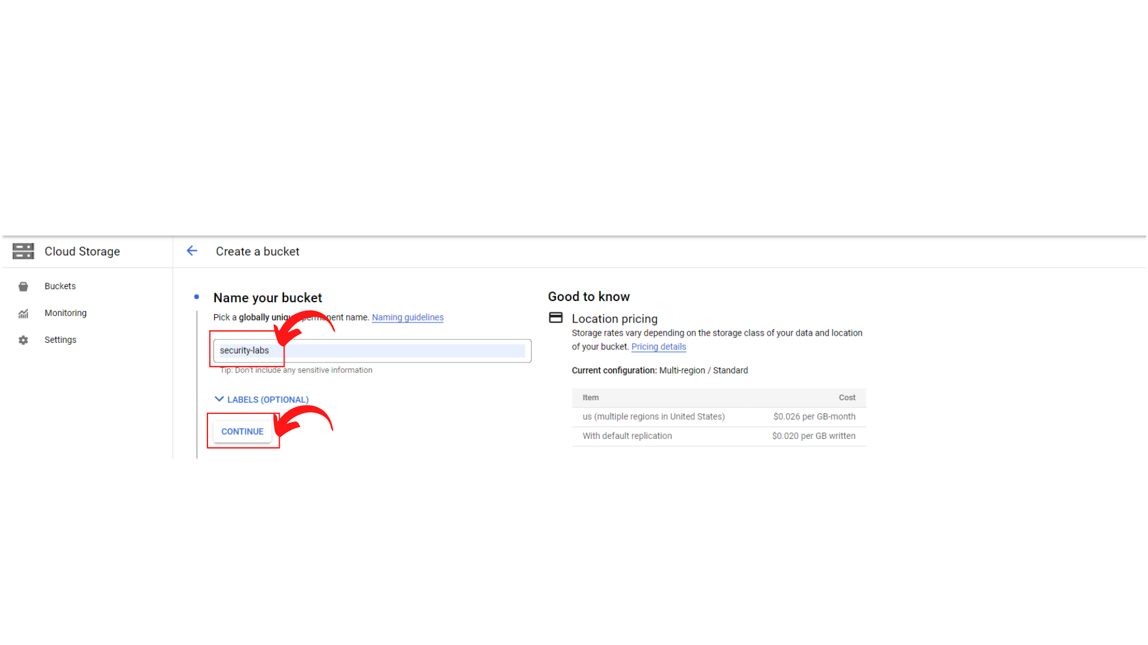

1. Now *Choose where to store your data* based on your region or any region you want and *“Click → Continue”*.

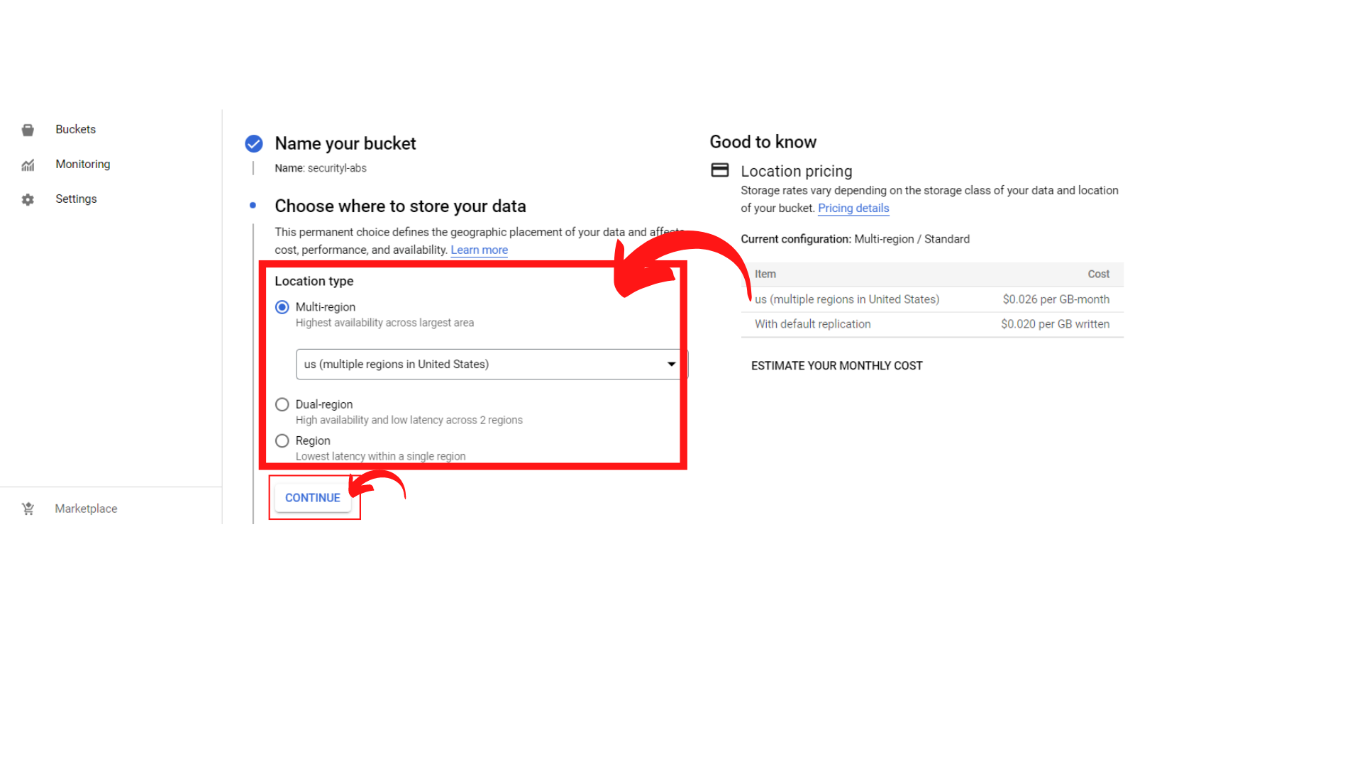

1. Now Choose a storage class for your data as per your choice and *“Click → Continue”*

Example: Here I’m leaving as default.

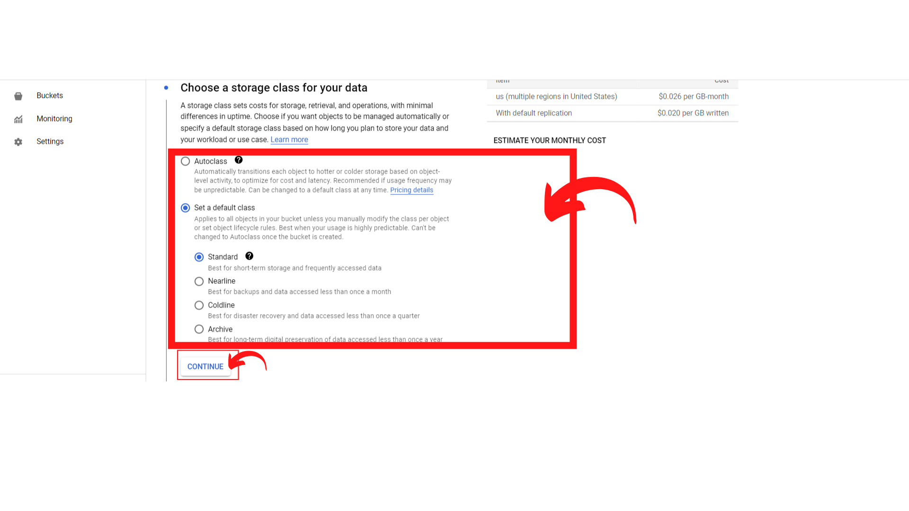

1. Now Choose how to control access to objects and *“Click → Continue”*

**Restrict data from being publicly accessible via the internet. Will prevent this bucket from being used for web hosting.**

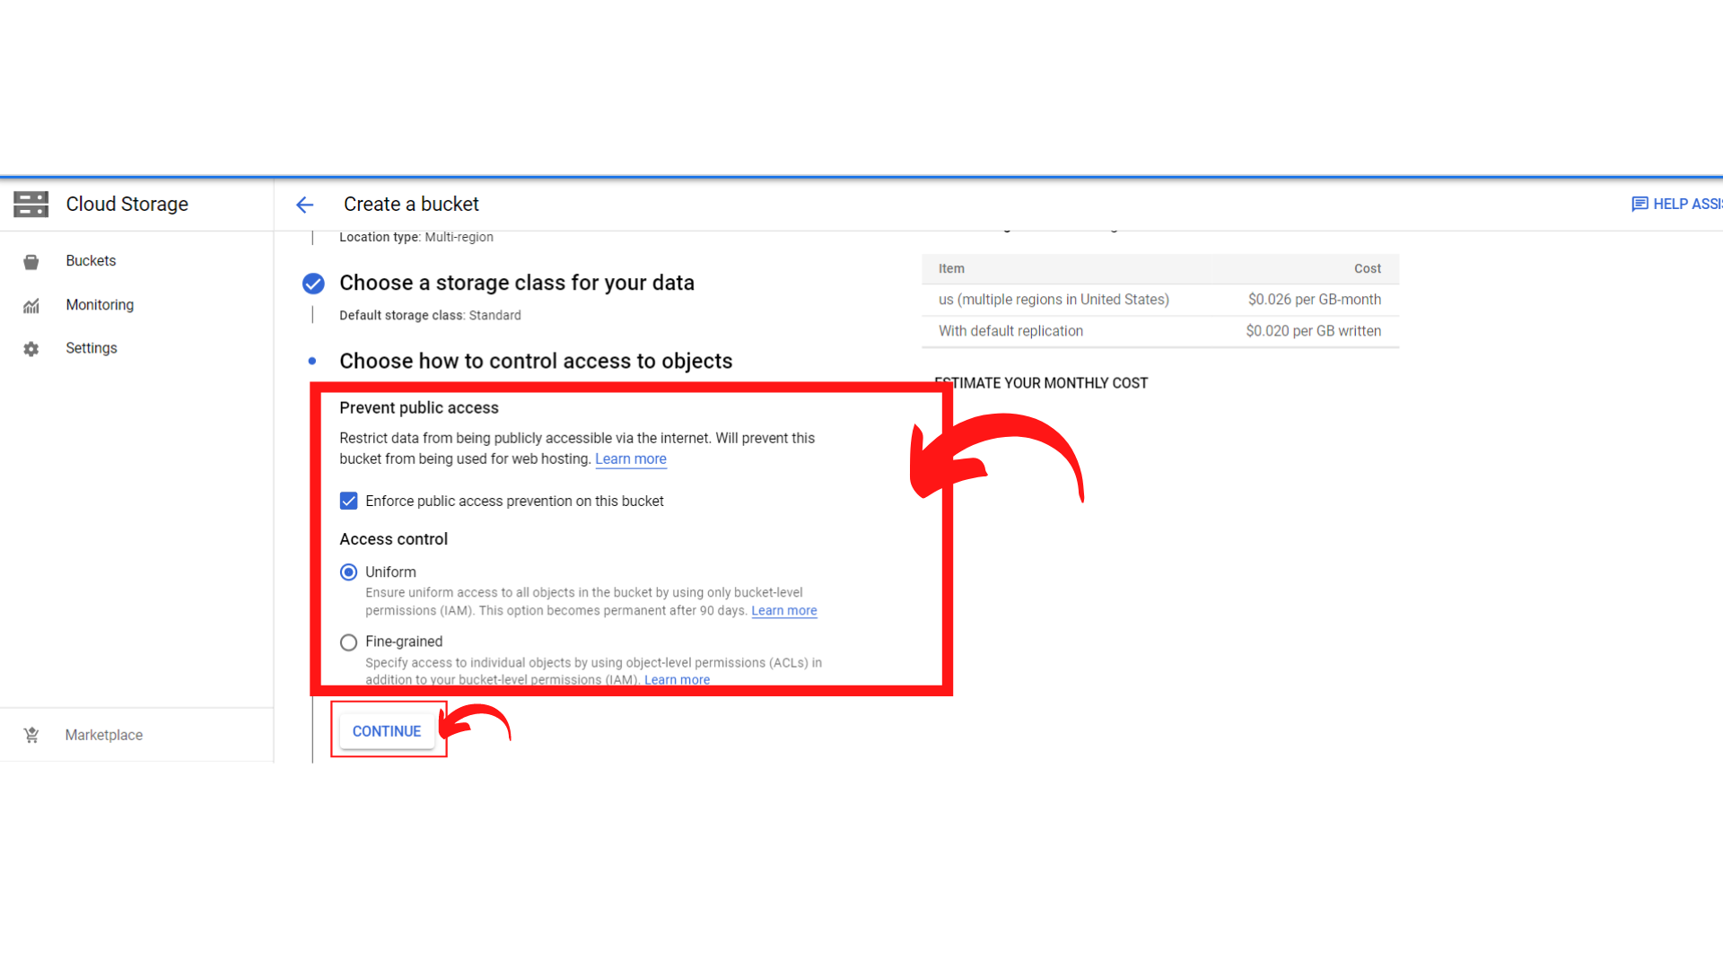

1. Now Choose how to protect object data and *“Click → Create”*

**Your data is always protected with Cloud Storage but you can also choose from these additional data protection options to prevent data loss and you can also do Data encryption by Google Cloud Key Management Service or Google managed Encryption key.**

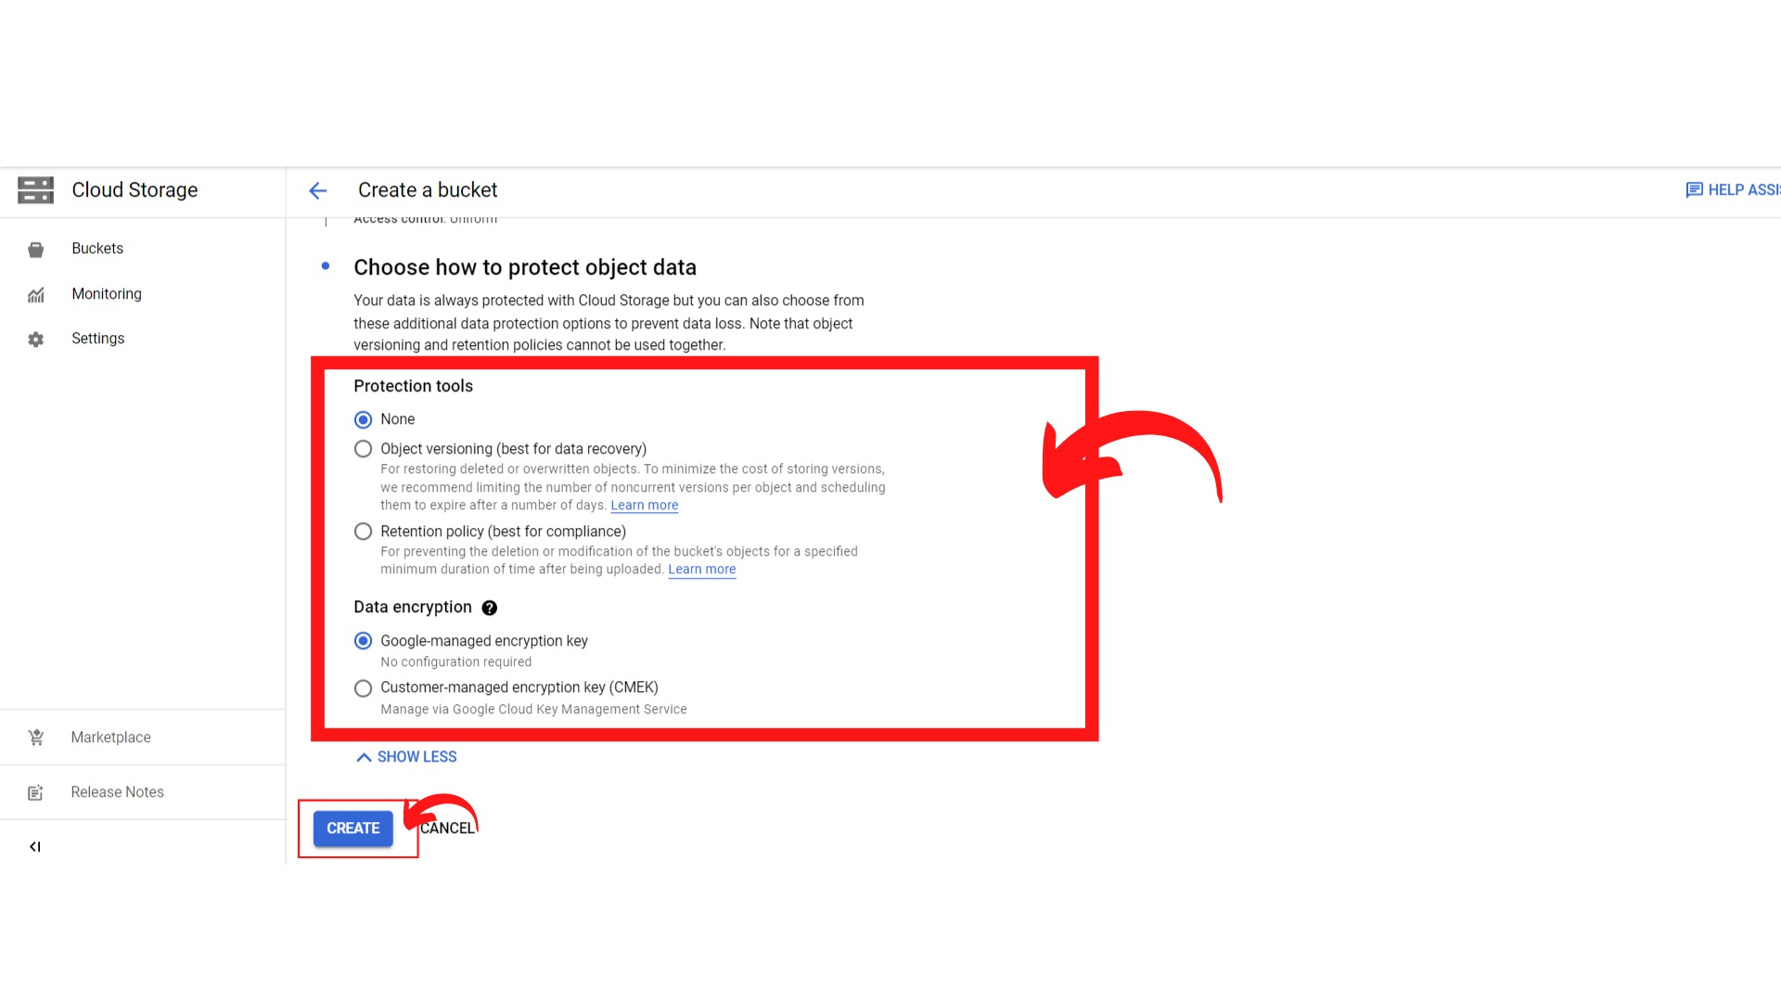

1. Then you get a notification to confirm “Public access will be prevented.” “Click → Confirm”

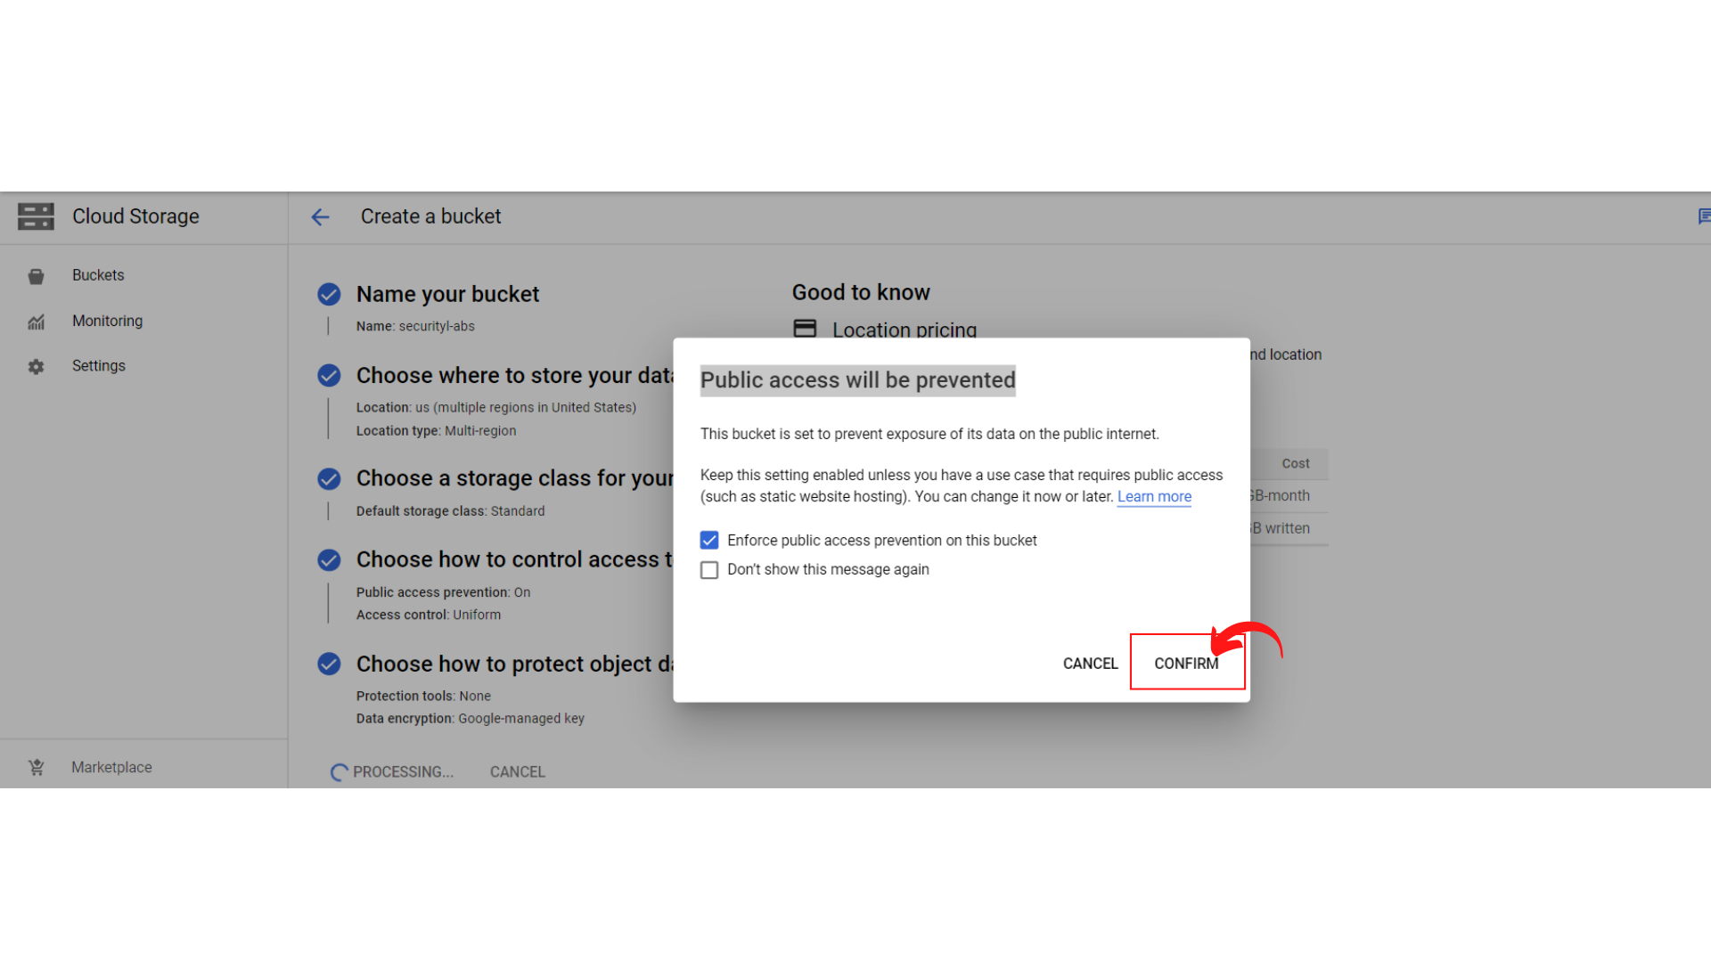

1. Your screen should look similar to this.

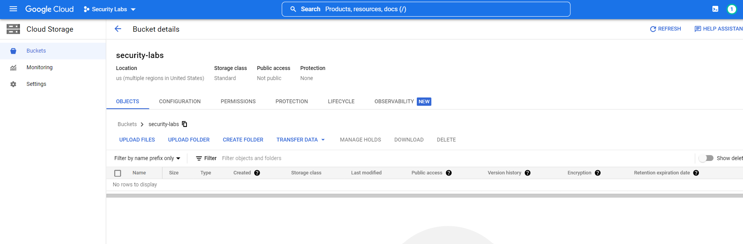

1. After the creation of the bucket, upload the files in the bucket by using the **upload files** option.

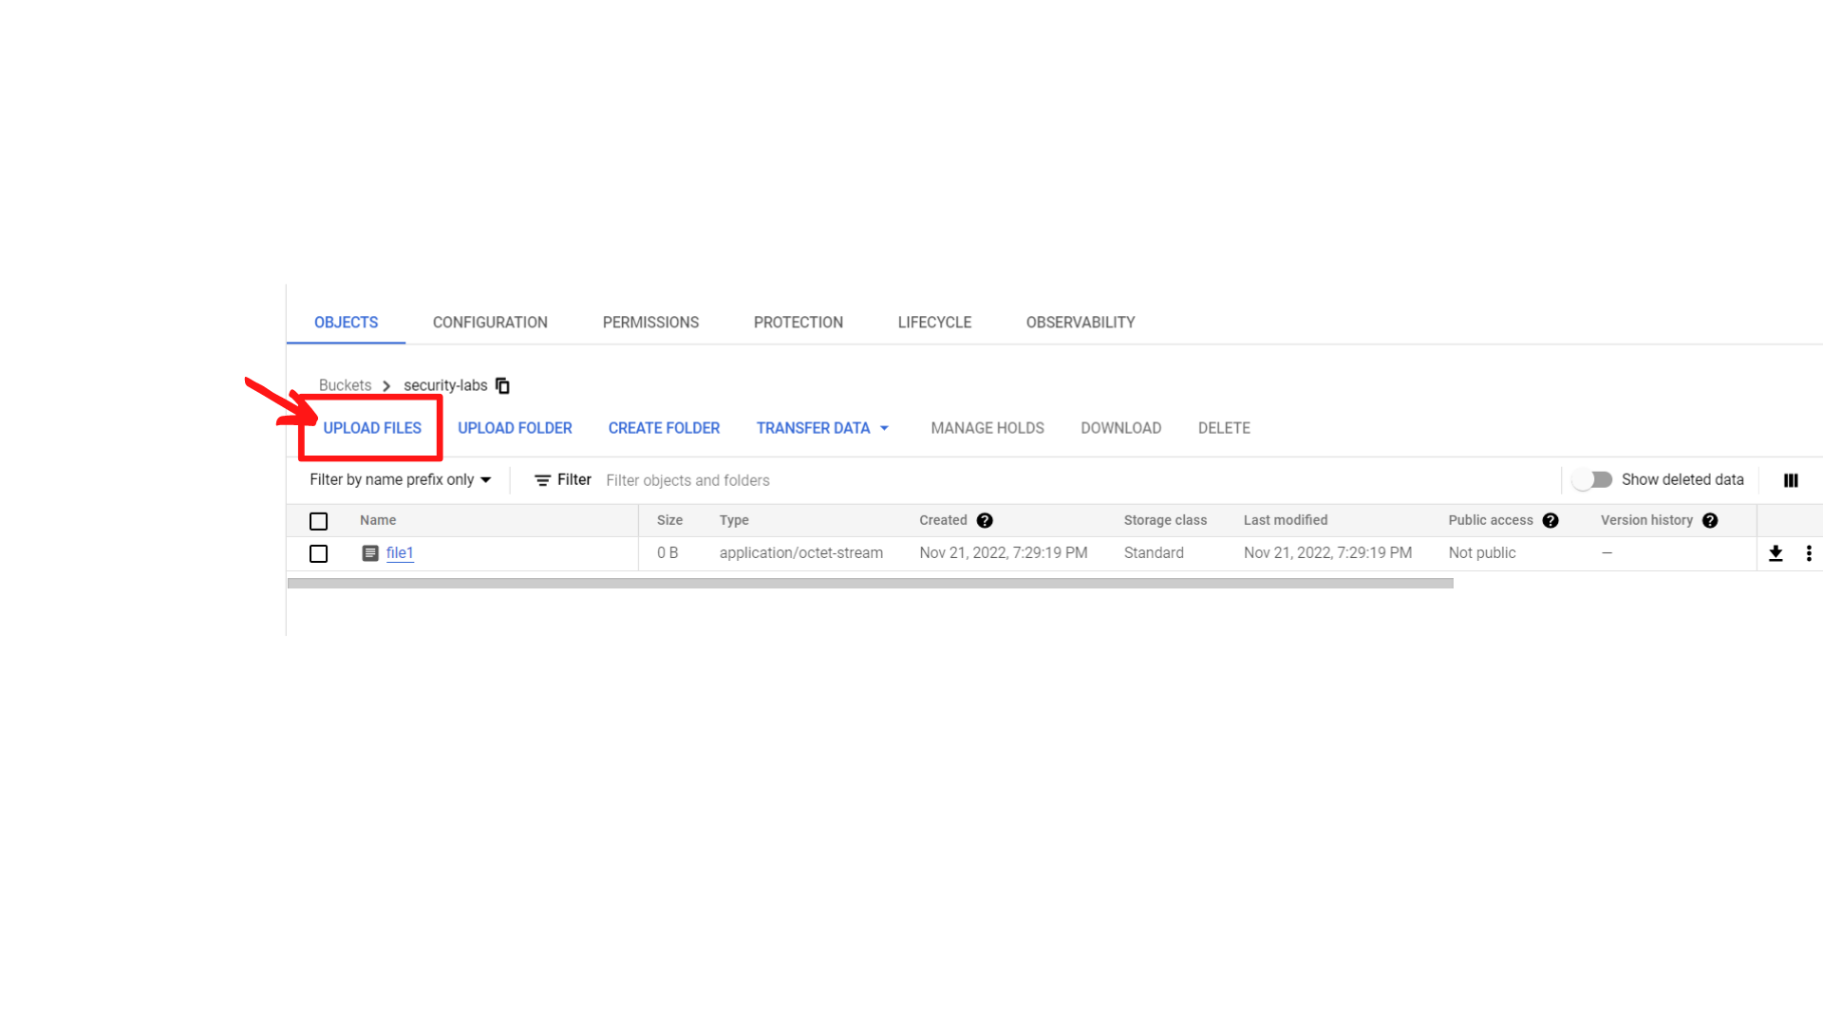

1. After uploading, you should see the uploaded files.

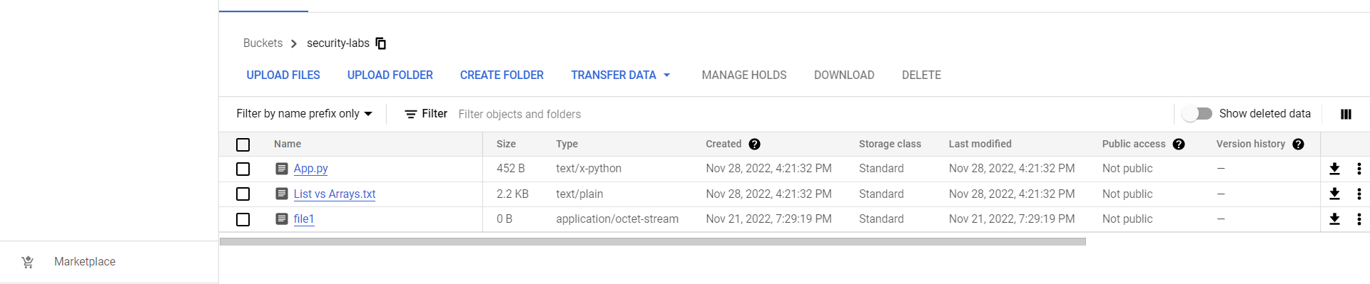

1. Now Click on *“Navigation menu”* on top left, then click on *“Security” → “Data Loss Prevention”*

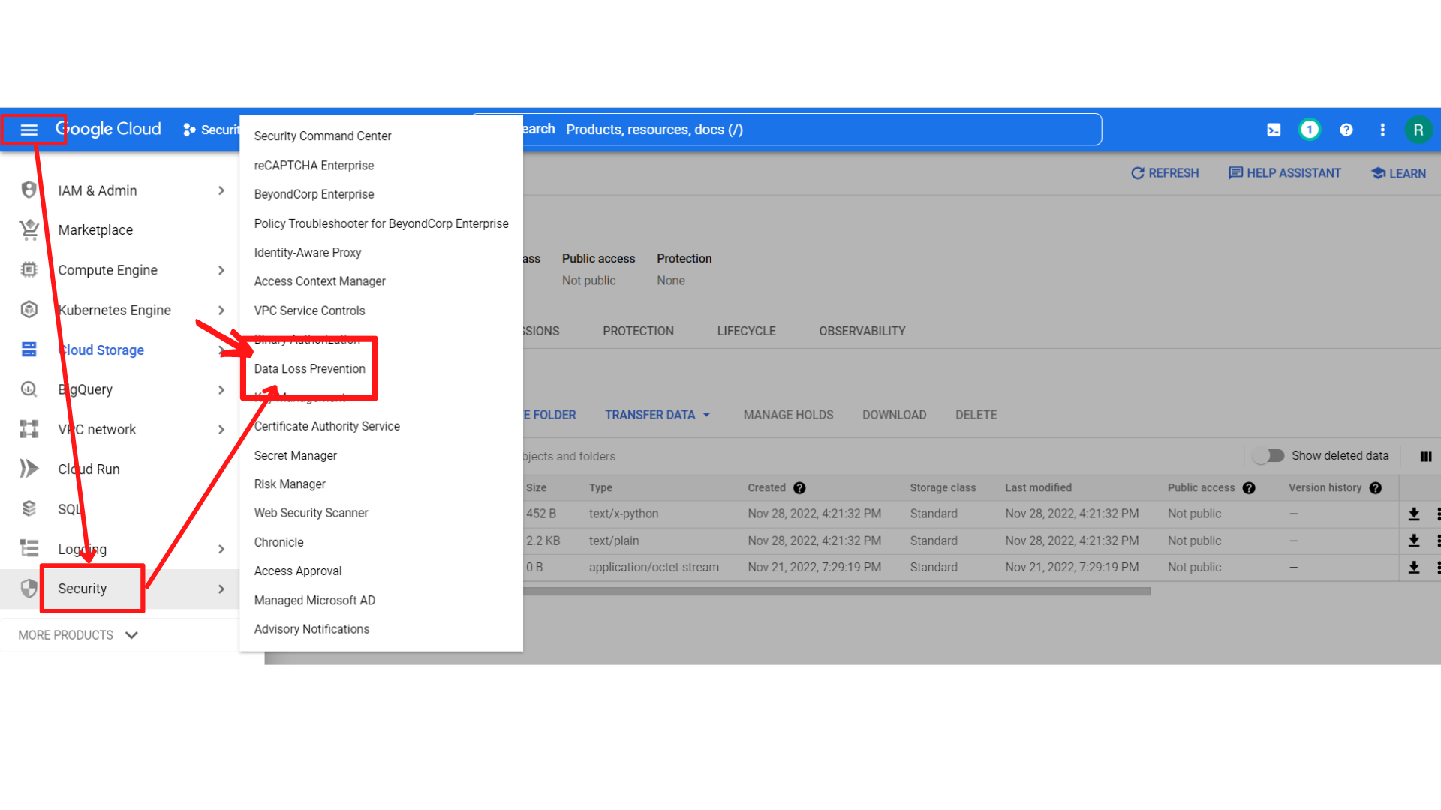

1. Your screen should look similar to this with Cloud Data Loss Prevention(DLP) API, ***“Click → Enable”***

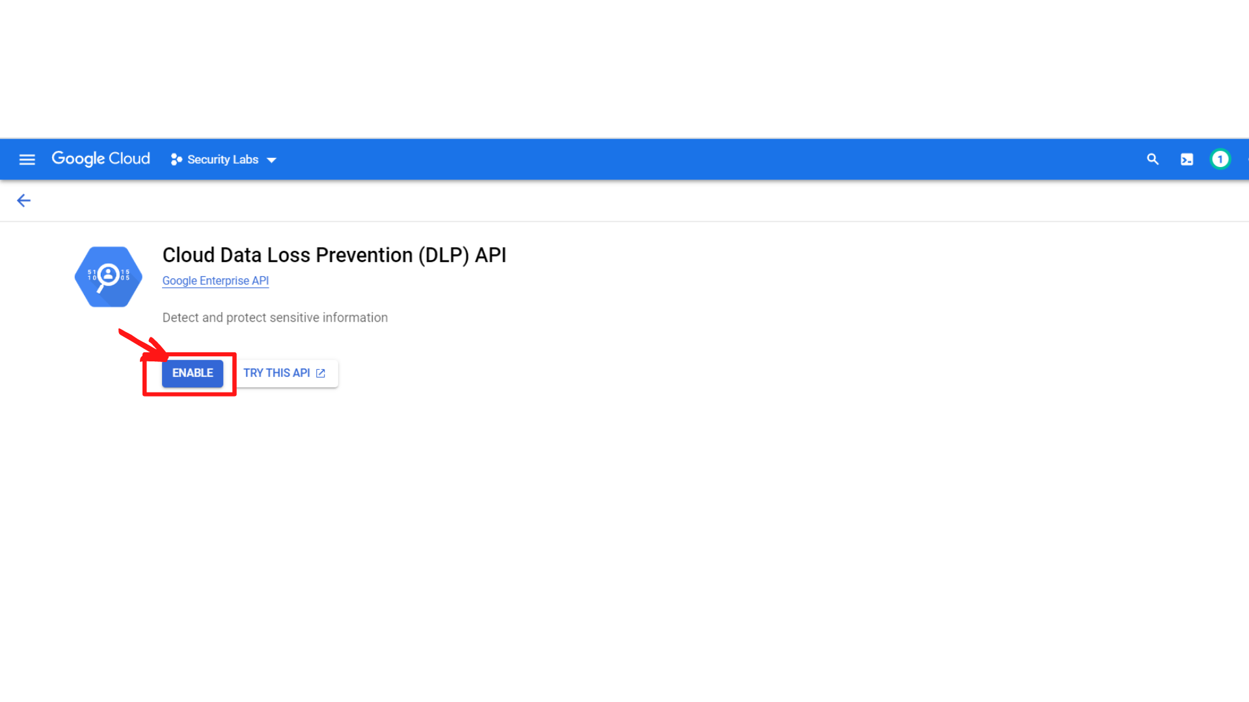

1. Your screen should look similar to this after enabling the API, ***“Click -- > SCAN CONFIGURATIONS”***

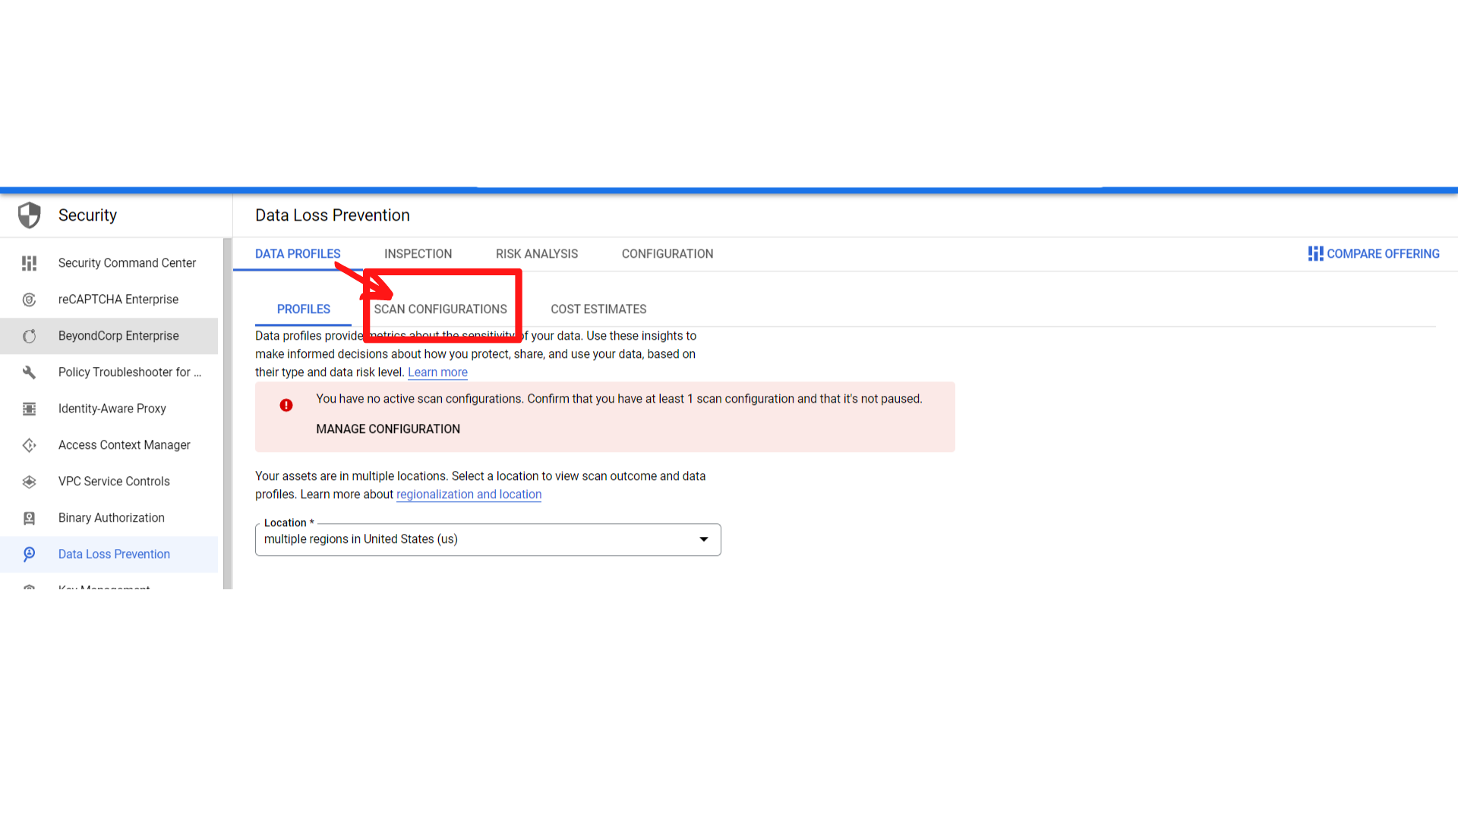

1. Now ***“click → Create Configurations”***

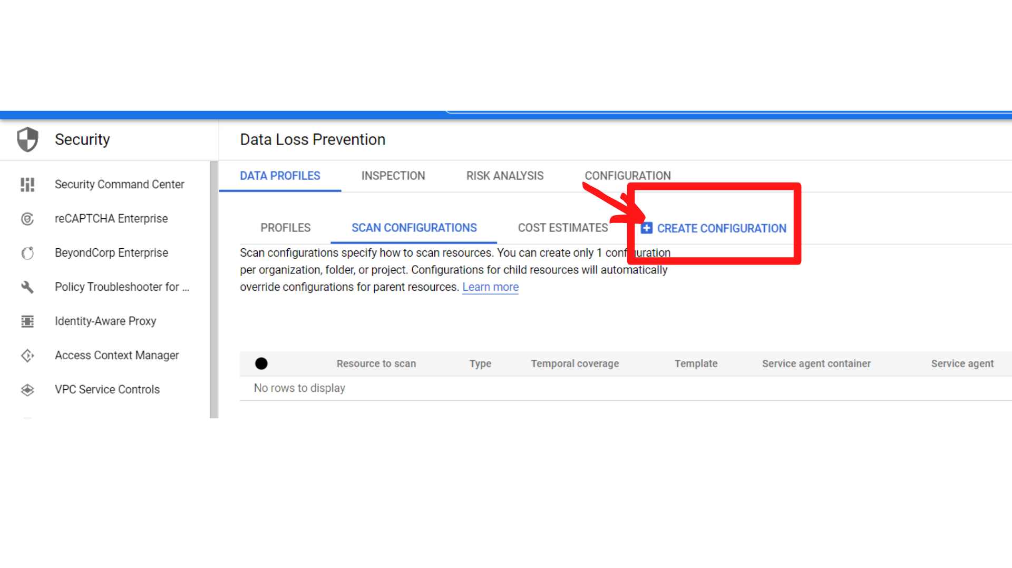

1. You will see the “Scan configuration form”; Enter the following:

**Select resource to scan :** Select **“entire Project”**, **click → Continue**

**Manage Schedules (Optional) :** **Leave this as default, Click → Continue**

**Select inspection template :** **Select “Create new inspection template”, Click → Continue**

**Add actions :** **Leave this as default, Click → Continue**

**Set location to store configuration :** **Select “multiple regions in United States (us)”, click → Continue**

**Review and create: Leave this as default**

**Then Click → Create**

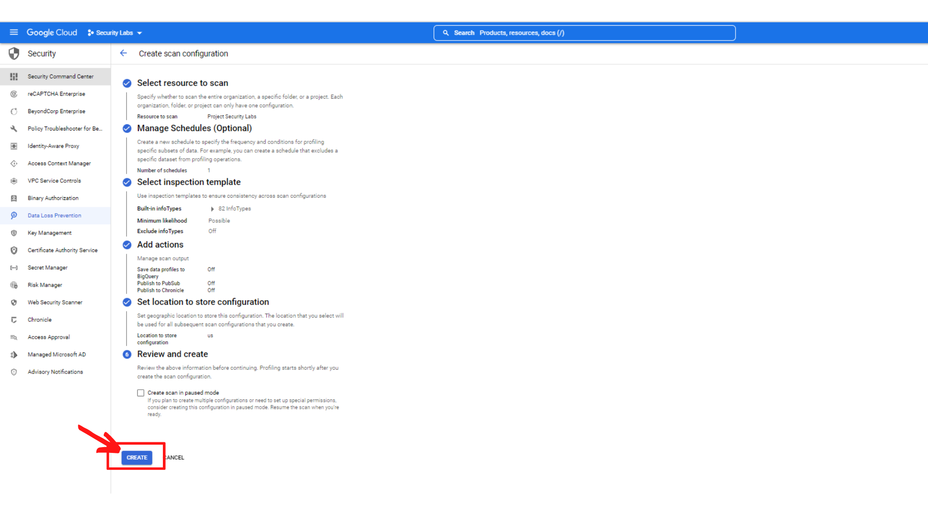

1. You should see the option at the bottom**(GO TO DATA PROFILES DASHBOARD)** after creating it. ***“CLick → Go to data profiles dashboard)”***

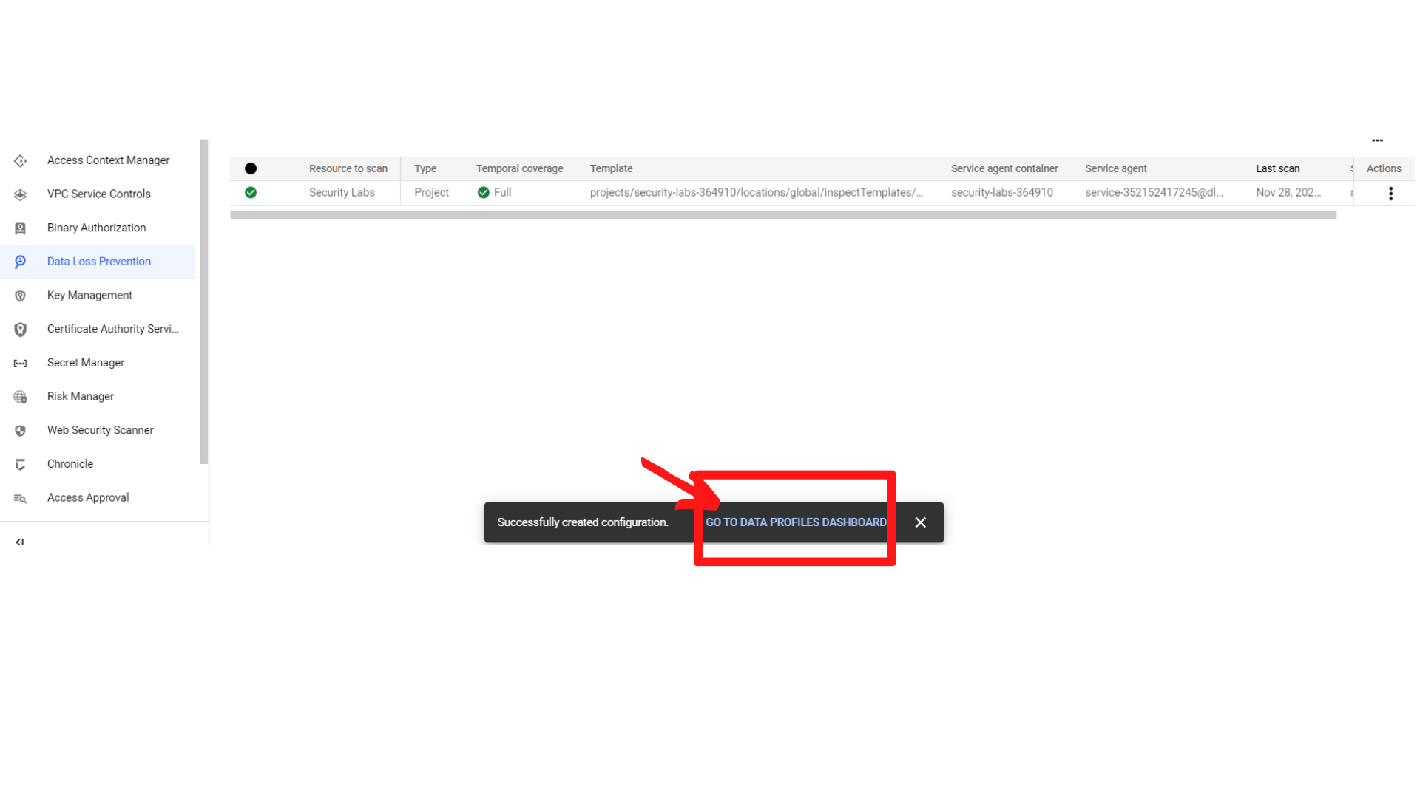

1. Your screen should look similar to this, **“Click → Inspection”**

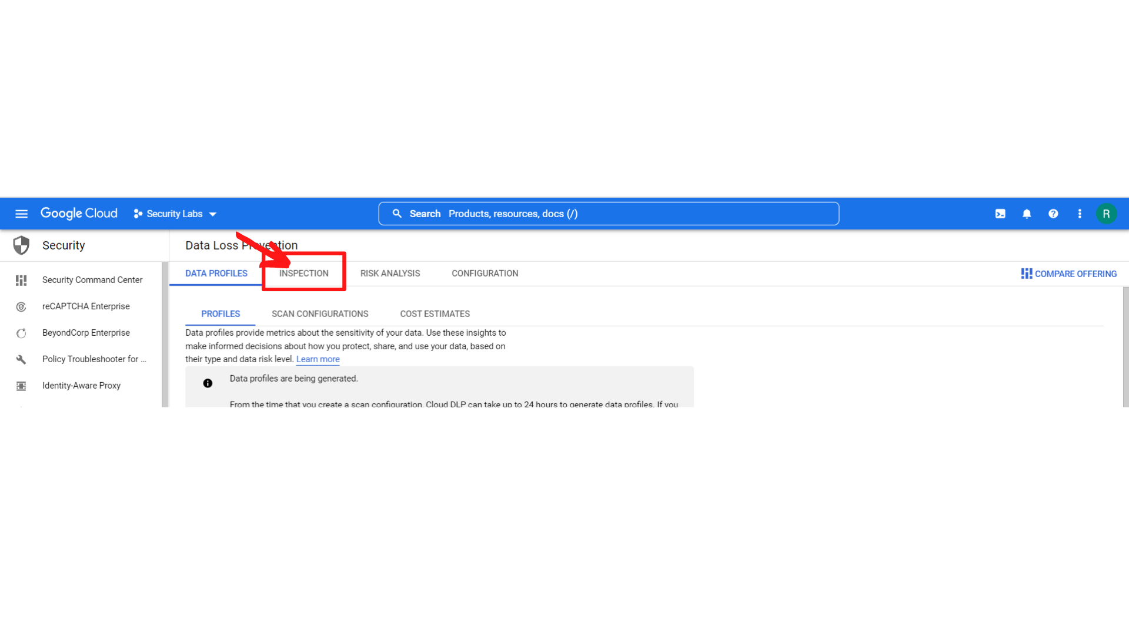

1. Your screen should look similar to this, **“Click →Create Job and Job Triggers”**

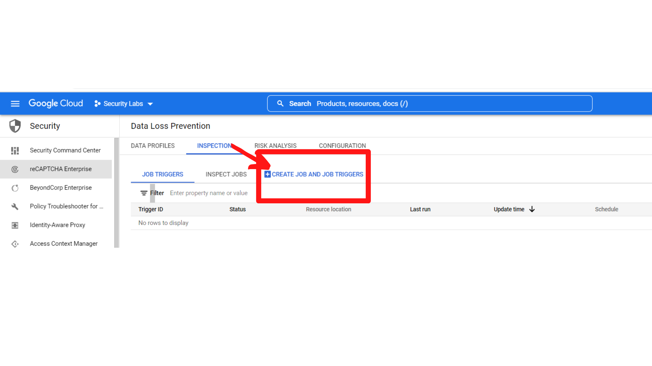

1. Your screen should look like this with Create job or Job trigger form.

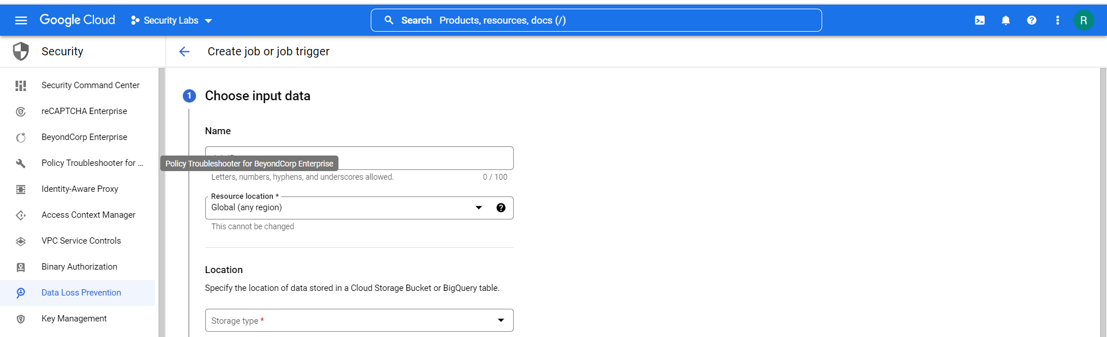

1. In the Create job or Job trigger form, Enter the following Information.

**Choose input data:**

**Name : As per your wish, Here Im entering “demo”**

**Resource Location:** Select **“Global (any region)”**

**Location:** Select **“Google Cloud Storage”**

**Location type:** select **“Scan a bucket with optional include/exclude rules”**

**Bucket Name: Browse the bucket you have created previously.**

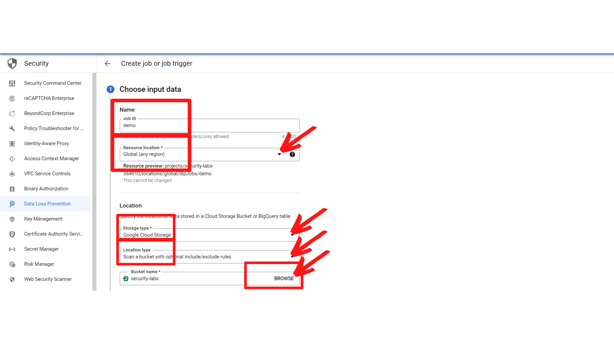

1. Now scroll down, You will see the sampling option. Enter the following information.

**Sample each object scanned :**

**Sampling method : Select “No sampling”**

**Files:**

**File types: Select “All supported file types”**

**“Click → Continue”**

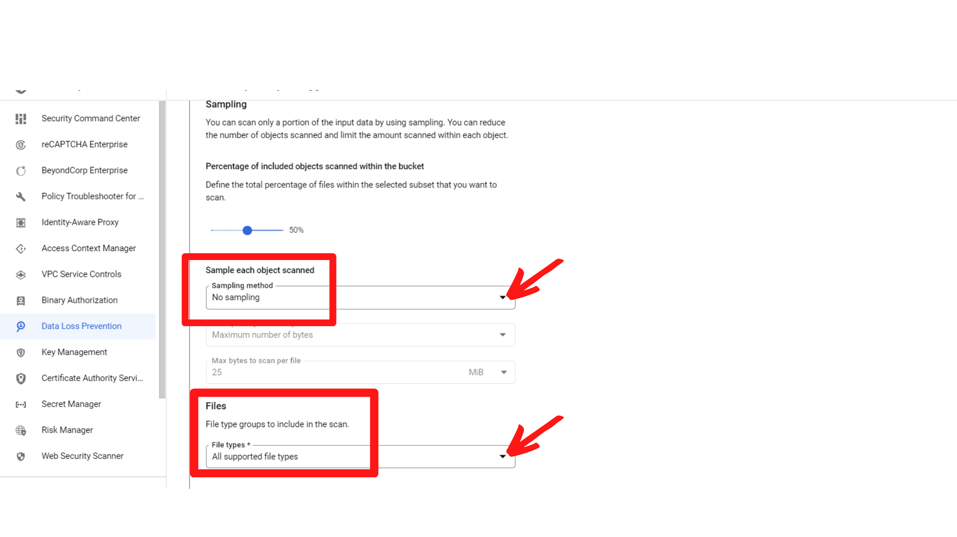

1. Now scroll down, Enter the following information in the form.

**Configure detection : Leave it as default, “click → continue”**

**Add actions : Leave it as default, “click → continue”**

**Schedule : Leave it as default, “click → continue”**

**Review : You will see the Job code, leave it as default**

**“Click→ Create”**

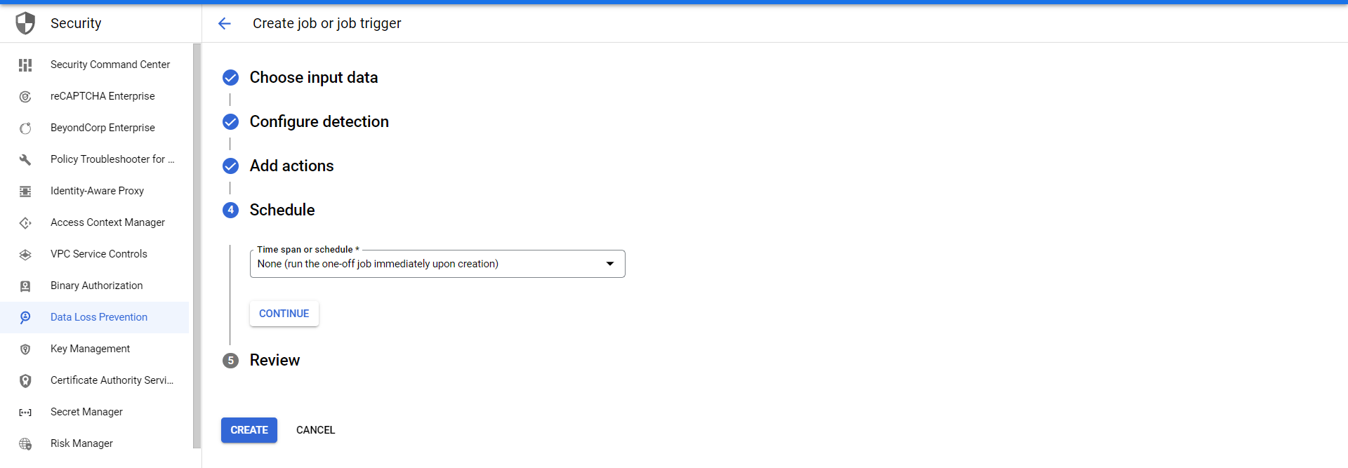

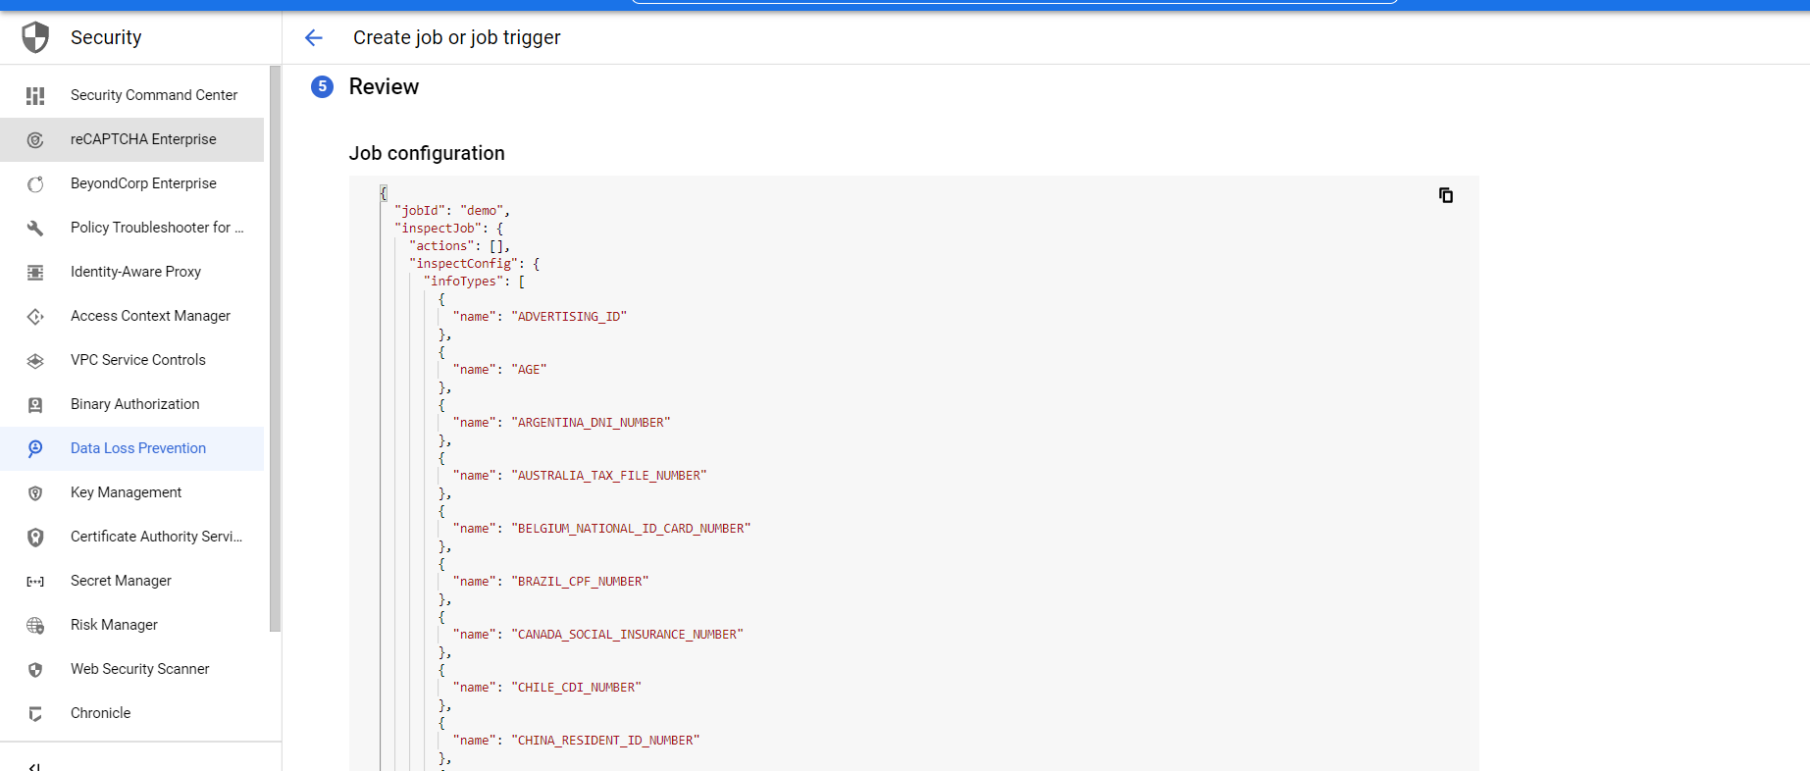

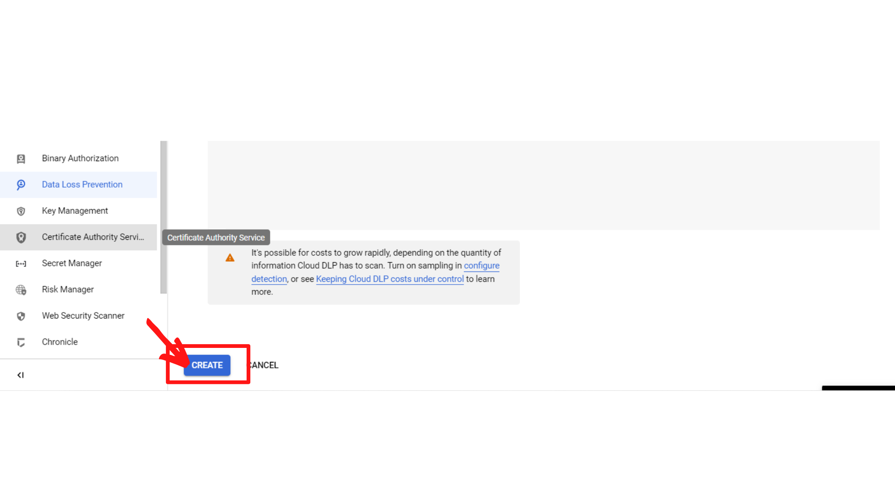

1. Once you click on create, you will get a popup to confirm, **“click → Confirm Create”**

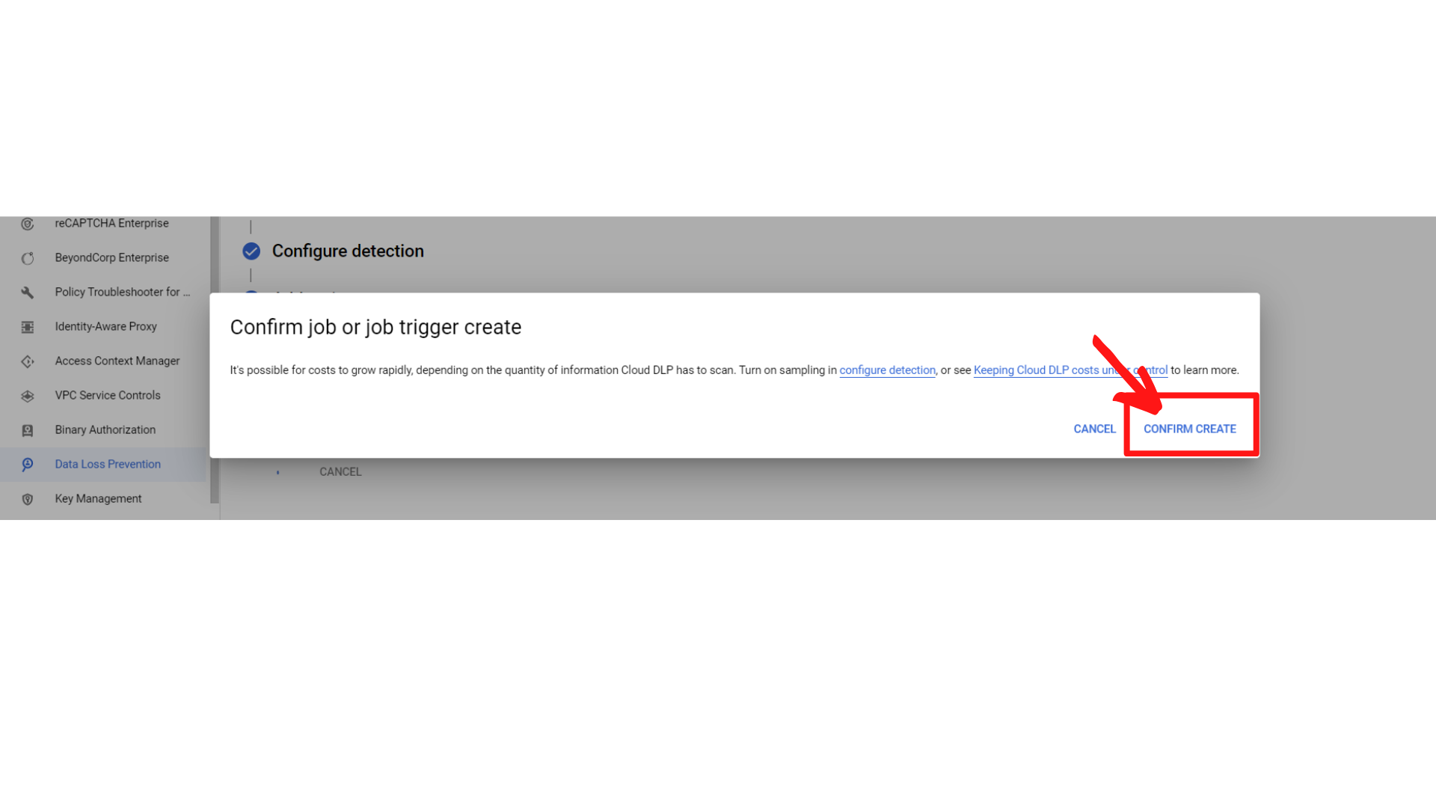

1. Please wait until it is created; after it is done you will see the job details that provide the number of finding in your bucket and bytes scanned with 0(zero) errors.

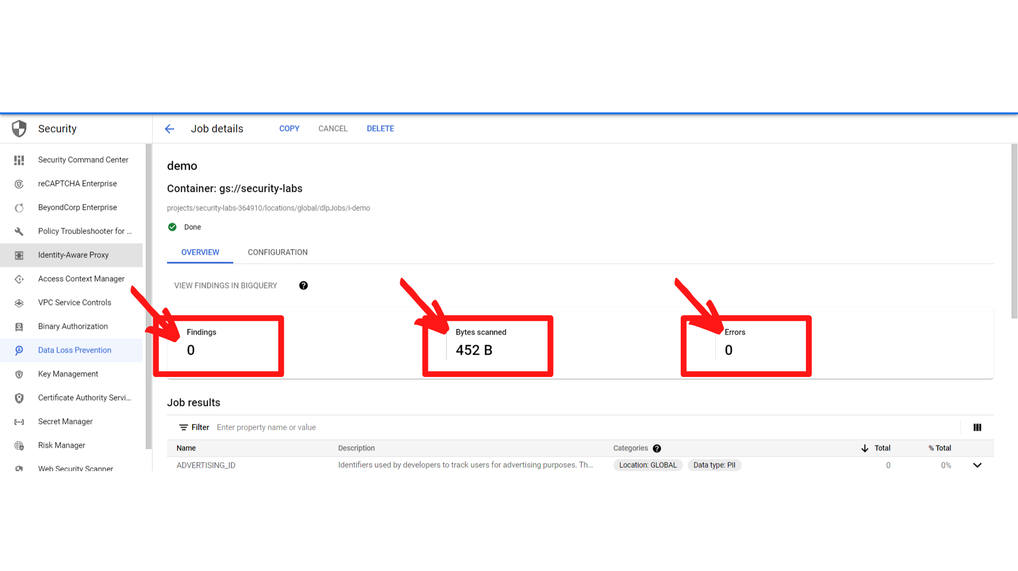

That’s it you have successfully created a job for your bucket that scans all your files in the storage bucket.